DATE: July 23, 2016

OPERATIONS MEMORANDUM #16-08-02

SUBJECT: Deactivating EBT cards for Deceased Households

TO: Executive Directors

FROM: Inez Titus
Director
Bureau of Operations

PURPOSE

This memo provides information on the appropriate steps to take to deactivate, also known as to status, an EBT card in the event that all persons in a SNAP household are deceased.

BACKGROUND

Currently, when all members of a household die (including single individual households) and the death is verified, the caseworker takes action to close the SNAP benefits. SNAP benefits are no longer being issued to the EBT card, but any unused benefits remain on the card until expunged. This leaves the benefits susceptible to fraud as the EBT card remains in an active status.

DISCUSSION

A recent audit brought to light issues with the current procedure when all persons in a SNAP household are deceased. OIM has developed a process where authorized individuals in the CAO would be able to deactivate/status EBT cards in situations where all household members are deceased.

This process begins with the CAO verifying that all persons in the household are deceased, closing the benefits, and sending the confirming notice. If the CAO has only verified the death of the household through exchange 8, then they must request additional verification and wait 10 days before taking action on the case. If the other verification is not received by the 10th day, then the case can be closed and the request to deactivate/status the EBT card can be sent to clerical via the HS 764.

REMINDER: Exchange 8 hits are NOT considered verified upon receipt for SNAP and additional verification of death is needed.

Completing the HS 764

- At the top of page one complete record number, Cat/PGM, name, date, prepared by worker, worker ID, and caseload number. Mark the ‘see other side’ box at the top of the form to indicate to the clerical team that the information they are looking for is on the other side of the form.

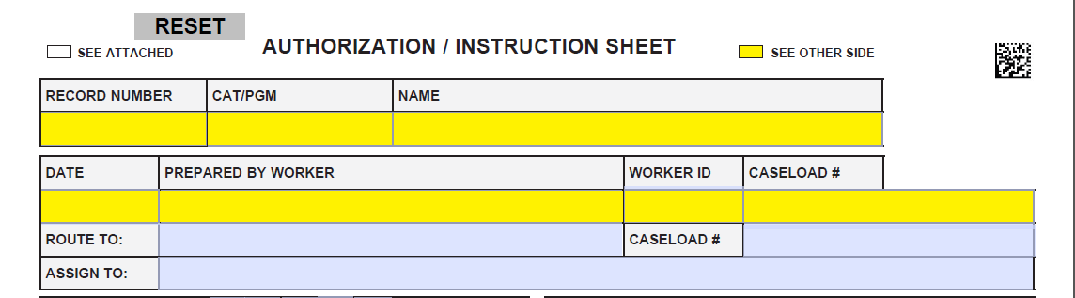

- At the bottom of page one the caseworker completes signature, worker ID, and date portion.

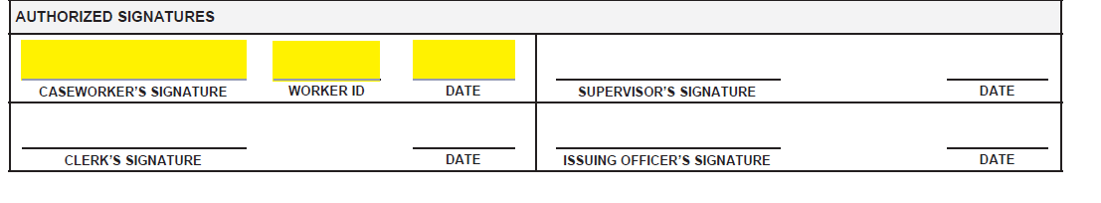

- At the bottom of page two the caseworker writes ‘card to be statused as ‘other’, all recipients in household deceased.’

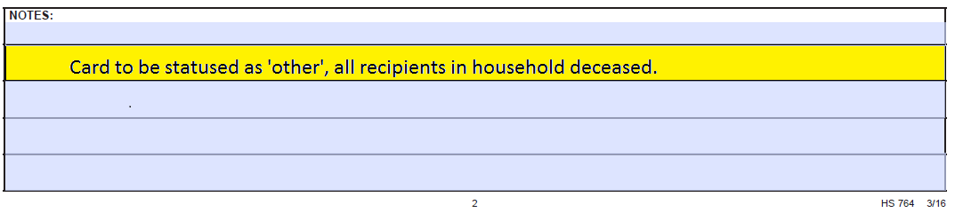

- The caseworker will then submit this form to their supervisor who will review, sign at the bottom of page one, and the forward onto the clerical team.

Statusing the EBT card
The authorized card makers and card pinners at the CAO will have access in the Electronic Payment Processing and Information Control (EPPIC) system to change the status of the EBT card to ‘Other’ following these directions:

- After you login into EPPIC, Select Client Account then Account Maintenance, enter the Client’s PA SUID, Card Number, Last and First Name or SSN under Client Search.
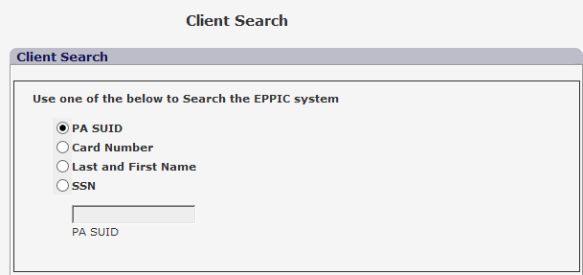

- Select Card in the lower right corner and the Client Card Management Screen will appear.
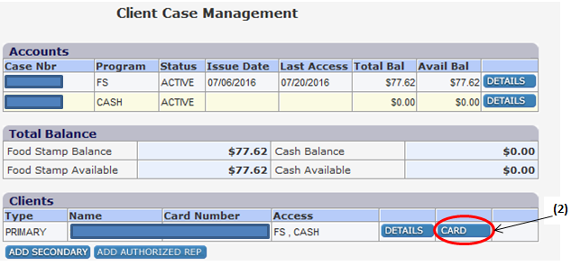

3. Select ‘Other’ from the drop down options
4. Click the Status button once you have selected the option ‘Other’
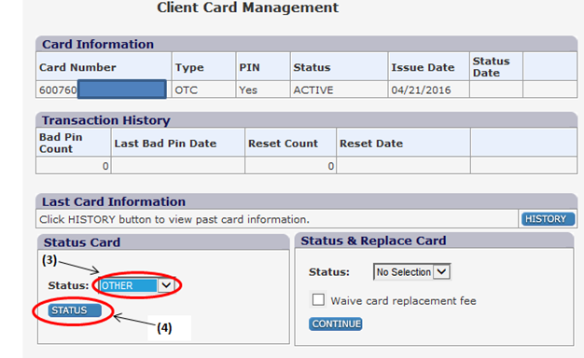
5. Click “OK” to confirm the process.
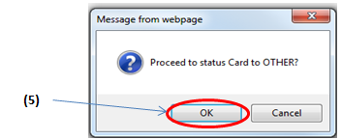
After the card is statused as ‘other’ it will not be able to be put back into ‘active’ status. In the event that a client was not deceased and the CAO received incorrect information, the CAO will be able to reissue a card to the client and waive the replacement fee of $2.50.

NEXT STEPS

- Share and review this information with appropriate staff members.

- Direct questions regarding this Operations Memorandum to your Area Manager.

- This Operations Memorandum will become obsolete when the SNAP Handbook has been updated.

