**Policy Clarifications**

**Other – PO-20165-740**

**Medicaid – PMA-20165-322**

**Cash Assistance – PCA-20165-122**

**SNAP – PFS-20165-522**

**Submitted: 09/25/2020 Agency: CAOs**

**Subject: Systematic Alien Verification for Entitlements (SAVE) Initial Verification Requests and Sponsorship Compliance**

**Question**: **Should the CAO complete the Sponsorship Compliance information on a SAVE Request?**

|  |  |  |  |
| --- | --- | --- | --- |
| **Response By: Division of Health Services** | **Date: 10/16/2020** |  |  |
|  |  |  |  |

No. The CAO will not utilize Sponsorship Compliance functionality on SAVE. This is a reporting tool for federal means-tested public benefits and may be used at the state agency’s discretion. Federal means-tested benefits include Medicaid, Children’s Health Insurance Program, Temporary Assistance for Needy Families, Supplemental Nutrition Assistance Program, and Supplemental Security Income.

After the SAVE case results appear, SAVE will ask (but not require) the user agency to answer questions on additional screens if the SAVE case results page includes sponsor or household member information. The CAO should choose to close the case without answering the questions by clicking the “Close Case” or “Close Case and Create New Case” button (Figure 1), then choose “Close Case” on the pop-up to confirm (Figure 2).

**NOTE:** Deeming of income and resources for sponsors should still be applied when necessary. See [MAEH Chapter 355 Deeming Income and Resources](http://services.dpw.state.pa.us/oimpolicymanuals/ma/355_Deeming_Income_and_Resources/355_Title.htm), [SNAP handbook Section 522.33 Sponsored Non-citizens](http://services.dpw.state.pa.us/oimpolicymanuals/snap/index.htm#t=522_Citizen_Noncitizen%2F522_3_Non-Citizens.htm), and [CAH Chapter 122 Citizen Noncitizen](http://services.dpw.state.pa.us/oimpolicymanuals/cash/index.htm#t=122_Citizen_Noncitizen%2F122_Title.htm) for more details.

**REMINDER:** Although the case is being closed, the CAO must retain the SAVE results in Imaging and utilize the information provided for each case.

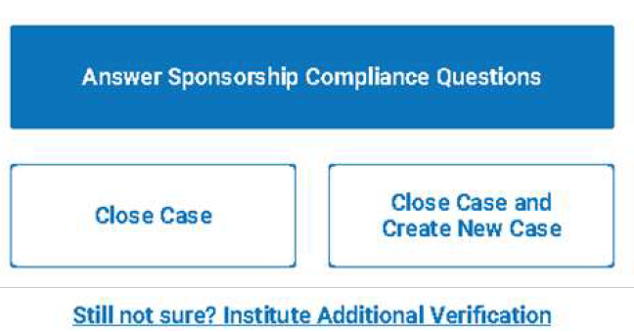

Figure 1

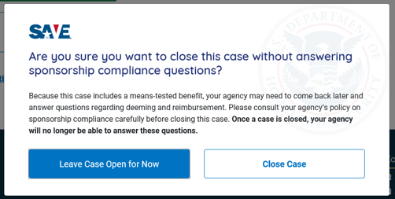  
  
Figure 2